**ORDINANCE NO . 2024-1**

**THE BOARD OF COUNTY COMMISSIONERS OF KIOWA COUNTY, COLORADO**

**TITLE: AN ORDINANCE FOR THE REGULATION OF TRAFFIC BY THE COUNTY OF KIOWA COLORADO; ADOPTING BY REFERENCE THE 2020 EDITION OF THE "MODEL TRAFFIC CODE" REPEALING ALL ORDINANCES IN CONFLICT THEREWITH; AND PROVIDING PENALTIES FOR VIOLATION THEREOF.**

**WHEREAS,** pursuant to§42-4-110(1), Colorado Revised Statutes ("C.R.S."), local authorities are granted the power to enact, adopt, and enforce traffic regulations on the roads and streets within the jurisdiction of the local authority, subject to the conditions and limitations set forth in such Section of the C.R.S.; and

**WHEREAS,** pursuant to *§* 42-1-102(48), a local authority is defined to include every county and other local board or body having authority to adopt police regulations under the constitution and laws of the State of Colorado for the unincorporated territory of the County; and

**WHEREAS,** pursuant to§ 42-4-l l 0(l )(b ), a local authority may in the manner prescribed in Article 15 of Title 30, C.R.S., adopt by reference all or any part of a model traffic code, which embodies the rules of the r_oad and vehicle requirements set forth in Article 4 of Title 42 including but not limited to§42-4-111, except that in the case of state highways, any such additional regulations shall have the approval of the Colorado Department of Transportation; and

**WHEREAS,** the Board of County Commissioners of Kiowa County ("the Board") has the authority to adopt police power ordinances under the Colorado Constitution and as authorized in Article 4 of Title 42, C.R.S., and in Article 15 of Title 30, C.R.S.; and

**WHEREAS,** the Board finds that the adoption of the 2020 version of the model traffic code is in the best interest of the public and will serve to preserve the public peace, health, safety and welfare of the citizens of Kiowa County;

**WHEREAS,** the Board, after proper notice as required by law, has held a public hearing on this ordinance providing for the adoption of the 2020 revised edition of the Model Traffic Code for Colorado.

**NOW THEREFORE, BE IT ORDAINED** by the Board of County Commissioners of Kiowa County, Colorado as follows:

**Section 1. Adoption.**

Pursuant to§ 42-4-l l 0(l)(b) and§ 30-15-401(l)(h), the Board of County Commissioners hereby adopts by reference the 2020 edition of the "Model Traffic Code" promulgated and published as such by the Colorado Department of Transportation, Traffic Safety and Engineering Services, 2829 W Howard Place, Denver, CO 80204. The subject matter of the Model Traffic Code relates primarily to comprehensive traffic control regulations for the Kiowa County, Colorado. The purpose of this Ordinance and the Code adopted herein is to provide a system of traffic regulations consistent with state law and generally conforming to similar regulations throughout the state and the nation. Three (3) copies of the Model Traffic Code adopted herein are now filed in the office of the Clerk of Kiowa County, Colorado, and may be inspected during regular business hours.

**Section 2. Deletions.**

The 2020 edition of the Model Traffic Code is adopted as if set out at length save and except the following articles and/or sections which are declared to be inapplicable to the County of Kiowa and are therefore expressly excluded and/or deleted from the Kiowa County Traffic Code:

|  |  |  |
| --- | --- | --- |
| Section 107 Section 510  Section 114 Section 511 | | Section 1409  Section 1412(12)(a) |
| Section 118 Section 611  Section 203 Section 711 & 713 | | Section 1413  Section 1415 |
| Section 227(3)(b) Section 1008.5 | | Section 1501 |
| Section 228(7) & Section 1012 (8)(b) | | Section 1715(2) & (3)  Sections 1801-1814  Sections 1901-1904 |
| Section 233 | Section 1101(12)(b) |
| Section 235 | Section 1102 |
| Section 238 | Section 1105 |  |
| Section 501 | Section 1208(6) and (8) the penalties related to third offenses only and 1208(7) and (11) in their entirety |  |
| Section 505 | Section 1212 | |

|  |  |  |
| --- | --- | --- |
| Section 507 | Section 1401 |  |
| Section 508 | Section 1402 |  |
| Section 509 | Section 1407(3)(c) |  |

**Section 3. Additions or Modifications.**

The 2020 edition of the Model Traffic Code is adopted as if set out at length in its entirety with the following additions or modifications:

1. All references made to "municipal", "municipality" or "municipalities" shall be deleted and "county" or "counties" be inserted in their stead.
2. All references made to "police officers" shall be deleted and "Sheriff", "deputy sheriff' or "deputy sheriffs" be inserted in their stead.
3. All references to the "Colorado Municipal Court Rules of Procedure (C.M.C.R.)" shall be deleted and the "Colorado Rules for Traffic Infractions", and/or the "Colorado Rules for County Court and Traffic Violations Bureaus" be inserted in its stead, as applicable.
4. Section 1209 delete "prosecutorial division of the appropriate jurisdiction" and insert in its stead, "the Kiowa County Sheriffs Office."

**Section 4. Penalties and Penalty Procedures.**

The following penalties, herewith set forth in full, shall apply to this ordinance:

* 1. It is unlawful for any person to violate any of the provisions adopted in this ordinance.
  2. Any person who violates any provision of this Ordinance commits a traffic infraction. Such a traffic infraction constitutes a civil matter. Except when otherwise prohibited herein, the penalty assessment procedure provided in Colo. Rev. Stat. § 42- 4-1701 (2008), may be followed by the assessing deputy for any such violation of this Ordinance. In addition to the penalties prescribed in this section, persons convicted of a violation of this Ordinance are subject to a surcharge as set forth in Colo. Rev. Stat. § 30- 15-402 (2004) and Colo. Rev. Stat. §42-4-1208 (2013). The fines and the surcharges shall be paid to the Kiowa County Sheriff by each defendant. The clerk shall transmit the surcharge to the court administrator of the 15th Judicial District for credit to the Victims and Witness Assistance and Law Enforcement Aid fund established pursuant to Colo. Rev. Stat. § 24-4.2-103 (2003), the Disabled Parking Education and Enforcement Fund pursuant to Colo. Rev. Stat. § 42-1-226 (2013) and the Colorado Traumatic Brain Injury Trust Fund established pursuant to Colo. Rev. Stat. § 26-1-309 (2002). Court costs, if any, shall be paid directly to the Clerk of the Court by each defendant.
  3. Traffic infractions are divided into two classes denoted by "TIA" for Class A Traffic Infractions, and "TIB" for Class B Traffic Infractions.

543

* 1. In the case of multiple traffic offenses involving aggressive driving, the applicable penalty or penalty assessment shall be doubled for each traffic offense. For purposes ofthis subsection, "aggressive driving" means committing any two or more ofthe following violations in a single act or series ofacts in close proximity to another motor vehicle: 1) exceeding the speed limits (1101); 2) following too closely (1008);

3) failure to obey official traffic control devices (603); 4) passing on shoulder ofroad (1004); 5) failure to give an adequate signal (903); 6) failure to yield right-of-way (701,

702, 703); and 7) unsafe lane change (903).

* 1. The penalties for violating specific Sections of this Ordinance shall be as follows:

**Vehicle Equipment**

|  |  |  |  |  |  |
| --- | --- | --- | --- | --- | --- |
| **Traffic Code** | **CRS** | **Violation Description** | **Class-fine or Summons** | **Common Code** | **Surcharge** |
|  | |
| 0201 | 42-4-201 | Obstruction ofview or interference with driving mechanism | TIA-$35.00 | 450 | $10.00 |
|  |  |
| 0202 | 42-4-202 | Unsafe vehicle | TIA-$35.00 | 542 | $10.00 |
| 0204 | 42-4-204 | When lighted lamps required | TIA-$15.00 | 611 | $6.00 |
| 0205 | 42-4-205 | Head lamps on motor vehicles | TIB-$15.00 | 613 | $6.00 |
|  |  | Tail lamps and reflectors | TIB-$15.00 | 615 | $6.00 |
| 0206 | 42-4-206 |
| 0207 | 42-4- 207 | Clearance and identification | TIB-$15.00 | 620 | $6.00 |
| 0208 | 42-4- 208 | Stop lamps and turn | TIB-$15.00 | 623 | $6.00 |
| signals | |
| 0209 | 42-4- 209 | Lamp or flag on a projecting load | TIA-$15.00 |  | $6.00 |

544

|  |  |  |  |  |  |  |
| --- | --- | --- | --- | --- | --- | --- |
| 0210 42-4- 210 Lamps on parked vehicles | | | TIB-$15.00 | 350 | | $6.00 |
| 0211 42-4- 211 Lamps on farm equipment  and other vehicles and equipment | | | TIB-$15.00 | 627 | | $6.00 |
| 0212 42-4- 212 Vehicle spot lamps and  auxiliary lamps | | | TIB-$15.00 |  | | $6.00 |
| 0213 42-4- 213 | | Audible and visual signals on emergency vehicle | TIA-$15.00 | 545 | | $6.00 |
| 0214 42-4- 214 | | Visual signals on a service vehicle | TIB-15.00 | 645 | | $6.00 |
| 0215 42-4- 215 | | Signal lamps, devices and additional lighting equipment | TIB-15.00 | 629 | | $6.00 |
|  | |
| **Vehicle Equipment Cont.** | | | | | | |
| **Traffic Code** | **CRS** | **Violation Description** | **Class- Fine or Summons** | **Common Code** | | **Surcharge** |
|  | |
| 0216 | 42-4-216 Multiple-beam Road lights | | TIB-$15.00 | 631 | | $6.00 |
| 0217 | 42-4-217 Use of multiple beam lights | | TIA-$15.00 | 632 | | $6.00 |
| 0218 | 42-4- 218 Single-beam road-lighting | | TIB-$15.00 | 634 | | $6.00 |
|  | equipment |
| 0219 | 42-4- 219 | Number oflamps permitted | TIB-$15.00 | 635 | | $6.00 |
| 0220 | 42-4- 220 | Motorized bicycles - motor driven cycles -  lighting equipment - department control- use and operation | TIB-$15.00 | 931 | | $6.00 |
|  |
| 0221 42-4-221 | | | Bicycle equipment | TIB-$15.00 | | 931 $6.00 | | |

|  |  |  |  |  |  |
| --- | --- | --- | --- | --- | --- |
| 0222 | 42-4- 222(1) | Volunteer firemen - volunteer ambulance | TIB-$15.00 | 638 | $6.00 |
| attendants - special lights | | | |
|  | | and alarm systems |  |
| 0223 | 42-4-223 | Brake equipment required | TIA-$15.00 | 549 | $6.00 |
| 0224 | 42-4-224 | Hom and warning devices | TIB-$15.00 | 551 | $6.00 |
| 0225 | 42-4-225 | Mufflers - prevention of noise | TIB-$15.00 | 552 | $6.00 |
| 0226 | 42-4-226 | Mirrors- exterior placements | TIB-$15.00 | 553 | $6.00 |
| 0227 | 42-4-227(2) | Windows unobstructed- certain materials prohibited -windshield wiper requirement. | TIB-$50.00 | 466 | $16.00 |
| **Vehicle Equipment Cont.** | | | | | |
| **Traffic Code** | **CRS** | **Violation Description** | **Class- Fine or Summons** | **Common Code** | **Surcharge** |
| 0228 | 42-4-228(1),  (2), (3), (5),  or (6) | Restrictions on tire equipment | TIA-$15.00 | 556 | $6.00 |
| 0229 | 42-4-229 | Safety glazing materials in motor vehicle | TIB-$15.00 | 572 | $6.00 |
| 0230 | 42A-230 | Emergency lighting equipment- who must carry | TIB-$15.00 | 640 | $6.00 |
| 0231 | 42-4-231 | Parking lights | TIB-$15.00 | 642 | $6.00 |
| 0232 | 42-4-232 | Minimum safety standards for | TIA-$15.00 | 161 | $6.00 |

|  |  |  |  |  |  |
| --- | --- | --- | --- | --- | --- |
|  |  | motorcycles and motor driven cycles |  |  |  |
| 0234 | 42-4-234 | Slow moving vehicle - display of emblem | TIB-$15.00 | 565 | $6.00 |
| 0236 | 42-4- 236 | Child restraint system/safety belt required | TIB-$65.00 | 574 | $16.00 |
| 0237 | 42-4-237 | Safety belt system - | TIB-$65.00 |  | $6.00 |
| mandatory use | | |
| 0239 | 42-4-239 (5)(a ) | Misuse of wireless telephone (second violation)  Misuse of wireless telephone by individual under 18 years of age (second violation) | TIA-$50.00 TIA-$100.00 TIA-$50.00 | 585  (586)  587 | $10.00 ($10.00)  $10.00 |
|  |
|  | (TIA-  $100.00) | (588) | ($10.00) |
| 0240 | 42-4-  240 | Low-speed electric vehicle equipment | TIB-$50.00 | 559 | $10.00 |
|  | requirements | |  |  |  |

**Overweight-Oversized Vehicles**

575

|  |  |  |  |  |  |
| --- | --- | --- | --- | --- | --- |
| 0512 | 42-4-512 | Operated vehicle/object/contrivance that caused damage to a highway/highway structure  - liability for damage to highway | TIA-$75.00 | 495 | $24.00 |

**Signals - Siims - Markings**

|  |  |  |  |  |  |
| --- | --- | --- | --- | --- | --- |
| **Traffic Code** | **CRS** | **Violation Description** | **Class- Fine or Summons** | **Common Code** | **Surcharge** |
| 0603 | 42-4- 603 | Obedience disregard) official traffic control devices | TIA-  $100.00 | 999 | $10.00 |
| 0604 | 42-4-604 | Traffic control signal legend | TIA 100.00 | 220 | $10.00 |
| 0605 | 42-4-605 | Flashing signals | TIA-  $70.00 | 310 | $10.00 |
| 0606 | 42-4-606 | Display of unauthorized signs or devices | TIA-  $15.00 | 311 | $6.00 |
| 0607 | 42-4-607(1) | Interference with official TIB- | | 314 | $16.00 |
| devices | $50.00 |
| 0607 | 42-4-607 | Interference with official | TIA-$100 | 312 | $32.00 |
|  | (2)( a) | devices |
| **Signals - Signs - Markings Cont.** | | | | | |
| **Traffic Code** | **CRS** | **Violation Description** | **Class- Fine or Summons** | **Common** | **Surcharge** |
| **Code** |  |
| 0608 | 42-4-608(1) | Signals by hand or signal device | TIA-  $70.00 | 436 | $6.00 |
| 0608 | 42-4-608(2) | Signals by hand or signal device | TIA-  $15.00 | 540 | $6.00 |
| 0609 | 42-4-609 | Method of giving hand arm signals | TIA-  $15.00 |  | $6.00 |

|  |  |  |  |  |  |
| --- | --- | --- | --- | --- | --- |
| 0610 | 42-4-610 | Unauthorized insignia | TIB-  $15.00 | 541 | $6.00 |
| 0612 | 42-4-612 | When signals are inoperative or malfunctioning | TIA-  $70.00 | 320 | $10.00 |
| 0613 | 42-4- 613 | Failure to pay toll established by regional | TIA-  $35.00 | 966 | $10.00 |
| transportation authority | |

**Right of Way**

|  |  |  |  |  |  |
| --- | --- | --- | --- | --- | --- |
| **Traffic CRS Violation Description Code** | | | **Class-**  **Fine or Summons** | **Common Code** | **Surcharge** |
|  | |  |
| 0701 42-4-701 | | Vehicles approaching or entering intersection | TIA-$70.00 | 371 | $10.00 |
| 0702 42-4-702 | | Vehicle turning left | TIA-$70.00 | 278 | $10.00 |
| 0703 42-4-703 | | Entering through highway - stop or yield intersection | TIA-$70.00 | 319 | $10.00 |
| 0704 42-4-704 | | Vehicle entering roadway | TIA-$70.00 | 374 | $10.00 |
|  |  |
| 0705 | 42-4-705 | Operation on approach of an emergency vehicle | TIA-$70.00 | 375 | $16.00 |
| 0706 | 42-4-706 | Obedience to railroad signal | TIA-$70.00 | 315 | $10.00 |
| **Right of Way Cont.** | | | | | |
| **Traffic CRS** | | **Violation Description Class-** | | **Common Code** | **Surcharge** |
| **Code** |  |  | **Fine or**  **Summons** |
| 0707 | 42-4-707 | Certain vehicles must stop at railroad grade crossmgs | TIA-$70.00 | 317 | $10.00 |
|  |

|  |  |  |  |  |  |
| --- | --- | --- | --- | --- | --- |
| 0708 42-4-708 | | Moving heavy TIB-$35.00 equipment at  railroad grade | | 318 | $10.00 |
|  |  | crossing |  |
| 0709 | 42-4-709 | Stop when traffic obstructed | TIA-$70.00 | 952 | $10.00 |
| 0710 | 42-4-710 | Emerging from or entering alley, driveway or building | TIA-$70.00 | 378 | $10.00 |
| 0712 | 42-4-712 | Driving in highway work area | TIA-$70.00 | 382 $10.00 | |

**Pedestrians**

|  |  |  |  |  |  |
| --- | --- | --- | --- | --- | --- |
| **Traffic Code** | **CRS** | **Violation Description** | **Class- Fine or Summons** | **Common Code** | **Surcharge** |
| 0801 | 42-4-801 | Pedestrian obedience to traffic control devices and traffic regulations | TIB-$15.00 | 401 | $6.00 |
| 0802 | 42-4-802(1), | Pedestrians' right- | TIA-$30.00 | 376 | $6.00 |
|  | (4), or (5) | of-way in crosswalk  (1) Failure to yield to Pedestrian where no traffic  signals in place. | TIA-$15.00 | 411 | $6.00 |
|  |  | (3) No pedestrian shall suddenly leave a curb in  front of a moving | TIA-$30.00  TIA-$30.00 | 203  377 | $6.00  $6.00 |
|  |  | vehicle.   1. Passing a vehicle that is yielding for a pedestrian 2. Failure to yield right-   of way to a pedestrian at a |  |  |  |
|  |  | signalized intersection |  |  |  |
| 0803 | 42-4-803 | Crossing at other than a crosswalk | TIB-$15.00 | 402 | $16.00 |

|  |  |  |  |  |  |
| --- | --- | --- | --- | --- | --- |
| **Pedestrians Cont.** | | | | | |
| **Traffic Code** | **CRS Violation Description** | | **Class- Fine or Summons** | **Common Code** | **Surcharge** |
|  |  |
| 0805 | 42-4-805 | Pedestrian was under the influence of alcohol or drug while on a roadway. Rider of an animal was under the influence of alcohol or drug while on a roadway | TIB-$15.00 TIB-$15.00 | 802  803 | $6.00  $6.00 |
|  | |
| 0806 42-4-806 | | Driving through safety zone prohibited | TIA-$70.00 | 145 | $10.00 |
| 0807 42-4-807 | | Drivers to exercise due care | TIA-$70.00 | 381 | $10.00 |
| 0808 42-4-808 | | Drivers and pedestrians, other than persons m wheelchairs, to yield to persons with disabilities | TIA-$70.00 | 380 | $10.00 |
|  | |

433

**Turning- Stoooing**

|  |  |  |  |  |  |
| --- | --- | --- | --- | --- | --- |
| **Traffic Code** | **CRS** | **Violation Description** | **Class- Fine or Summons** | **Common Surcharge** | |
| **Code** |  |
| 0901 | 42-4-901 | Required position and method of turning - (right and left) | TIA-$70.00 | 273 | $10.00 |
| 0902 | 42-4-902 | Limitations on turning around (U- turn) | TIA-$70.00 | 270 | $10.00 |
| 0903 | 42-4-903 | Turning movements and required signals | TIA-$70.00 |  | $10.00 |

**Driving- Overtaking- Passing**

|  |  |  |  |  |  |
| --- | --- | --- | --- | --- | --- |
| **Traffic Code** | **CRS** | **Violation Description** | **Class- Fine or Summons** | **Common Code** | **Surcharge** |
| 1001 | 42-4-1001 | Drive on right side exceptions | TIA-$70.00 | 250 | $10.00 |
| 1002 | 42-4-1002 | Passing oncoming | TIA-  $100.00 | 190 | $10.00 |
|  | vehicles | |
| 1003 | 42-4-1003 | Overtaking vehicle on left | TIA-  $100.00 | 193 | $10.00 |
| 1004 | 42-4-1004 | When overtaking on | TIA-  $100.00 | 194 | $10.00 |
|  | | right is permitted |
| 1005 | 42-4-1005 | Limitations on overtaking on left | TIA-  $100.00 | 195 | $10.00 |
| 1006 | 42-4-1006 | Drove the wrong way on a one-way roadway and rotary traffic islands | TIA-$70.00 | 256 | $10.00 |
|  | |
| 1007 | 42-4-1007 | Driving on roadways laned for traffic | TIA-  $100.00 | 222 | $10.00 |
|  |  |
| 1008 | 42-4-1008 | Following too closely | TIA-  $100.00 | 142 | $10.00 |
| 1009 | 42-4- 1009 | Coasting prohibited | TIA-$70.00 | 147 | $10.00 |
| 1010 | 42-4-1010 | Driving on divided or controlled access highway | TIA-$70.00 | 253 | $10.00 |
| 1011 | 42-4-1011 | Use of runaway vehicle ramp | TIA-$200.00 | 231 | $32.00 |
| 1012 | 42-4-1012 | High occupancy vehicle lane (Three or more times - within a 12 month period) | TIA-$65.00 ($125.00) | 232 | None |
| 1013 | 42-4-1013 | Passing lane | TIA-$100.00 | 204 | None |

**Speed Regulations**

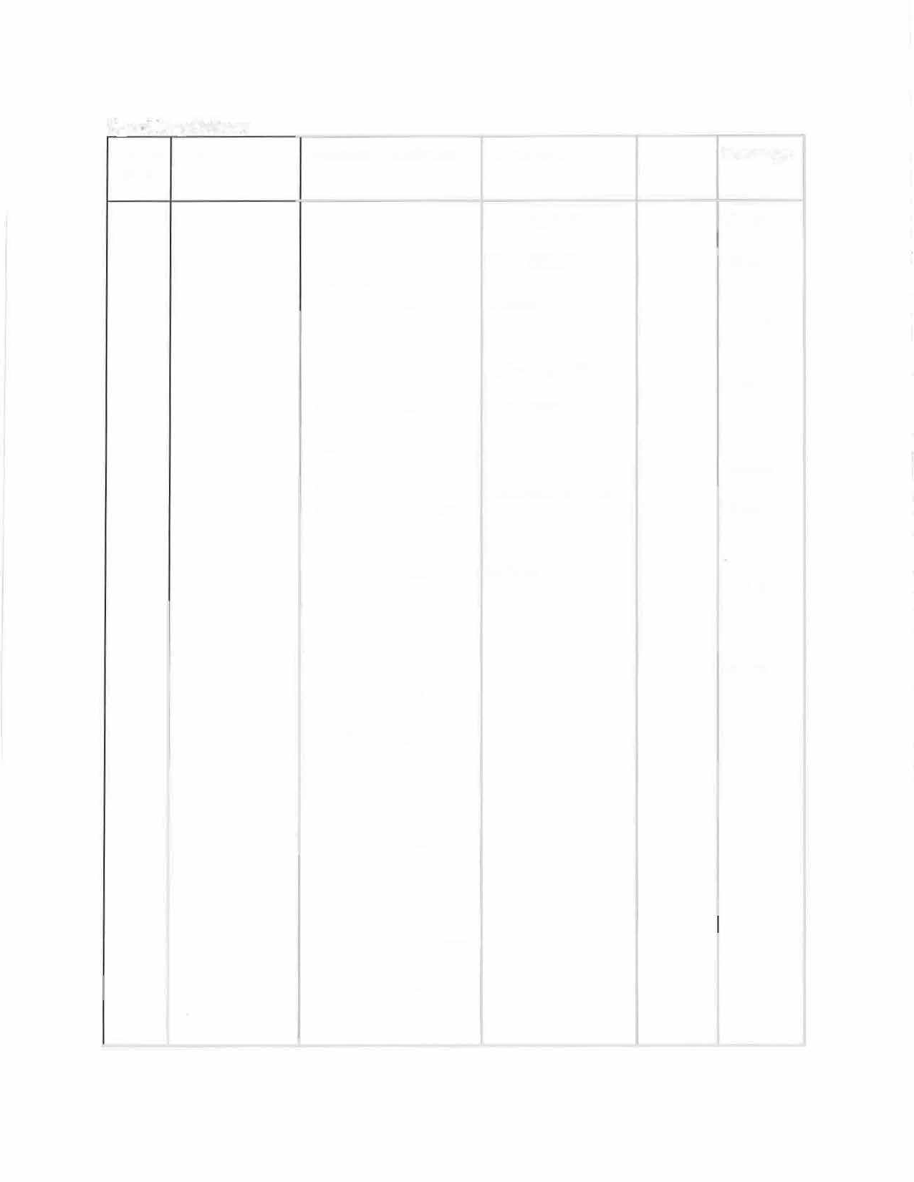

**Traffic CRS Violation Description Code**

1101 42-4-1101 Driving too fast for

conditions

Speeding 1-4 miles per hour over the posted limit

Speeding 5-9 miles per hour over the posted limit

Speeding 10-19 miles per hour over the posted limit

Speeding 20-24 miles per hour over the posted limit

Speeding 1-4 miles per hour over the posted speed limit driving a low- power scooter

Speeding 5 to 9 miles per hour over the posted speed limit driving a low- power scooter

Speeding greater than 9 miles per hour over the posted speed limit driving a low-power

scooter

**Class- Fine or Summons**

TIA $100.00 TIA-$30.00 TIA-

$70.00

TIA- $135.00 TIA-$200.00

TIA-$50.00 TIA-

$75.00

TIA-

$100.00

**Common Code**

007

020

004

005

006

021

022

023

**Sut'charge**

$25.00

$6.00

$10.00

$16.00

$32.00

$6.00

$10.00

$1600

|  |  |  |  |  |  |
| --- | --- | --- | --- | --- | --- |
|  |  | * Speeding fines doubled in a school/construction/wildlife crossing zone |  |  |  |
|  | |
|  |  |
| 1103 | 42-4-1103 | Impeding normal flow of traffic | TIA-$50.00 | 008 | $6.00 |

**Parking Regulations**

|  |  |  |  |  |  |
| --- | --- | --- | --- | --- | --- |
| **Traffic Code** | **CRS** | **Violation Class- Fine or** | | **Common Code** | **Surcharge** |
| **Description** | **Summons** |
| 1201 | 42-4- 1201 | Starting parked vehicle | TIA- $30.00 | 144 | $6.00 |
| 1202 | 42-4-1202 | Parking or abandonment | TIB- $30.00 | 350 | $6.00 |
| of vehicles | |
| 1204 | 42-4-1204 Stopping, standing, or parking prohibited in specific places | | TIB-$15.00 | 350 | $6.00 |
|  |
| 1205 | 42-4-1205 Parking at curb or shoulder of | | TIB-$15.00 | 350 | $6.00 |
| a roadway | | |
| 1206 42-4-1206 Unattended motor | | | TIB- $15.00 | 350 | $6.00 |
| vehicle | | | |
| 1207 42-4- 1207 Opening and closing  vehicle doors | | | TIB- $15.00 | 916 | $6.00 |

1208 42-4- 1208 Parking privileges TIA-

362

$32.00

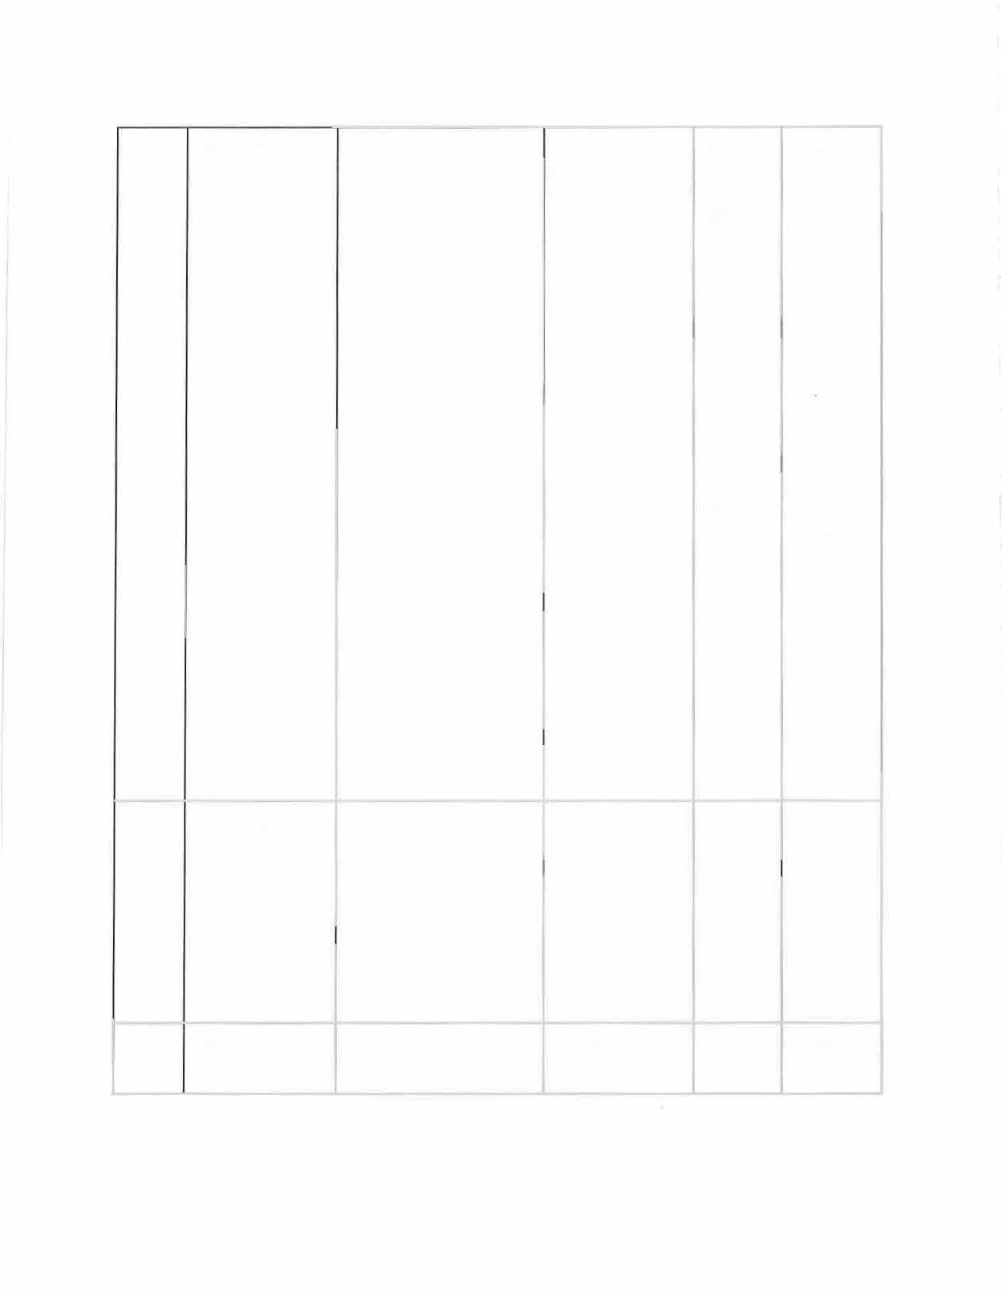

1208 42-4- 1208

cont.

1211 42-4-1211

for persons with disabilities-

(5) Unauthorized parking in designated disabled parking spot (second offense)

(3)(d)(l) Use of disabled

placard by employee of

company that transports.

disabled individuals when not transporting disabled individuals

(4) Unlawful to park a vehicle so blocking curb ramps, passenger loading zones, or accessible routes (second offense)

(15) Violation of time limits for reserved disabled parking spot

(16) Use of business disabled placard or license for non- business purposes -- Fines doubled for commercial carriers who violate subsections (5) or

(10)

Limitations on backing (unsafe)

$150.00

(TIA-

$150.00) TIB-

$100.00

TIA-

$150.00

(TIB-

$150.00) TIB-

$150.00

TIB-

$150.00

TIA-$30.00

362

368

369

153

$32.00

$10.00

$32.00

\\2.00

$3

$10.00

$10.00

$6.00

**Other Offenses**

|  |  |  |  |  |  |  |
| --- | --- | --- | --- | --- | --- | --- |
| **Traffic Code** | **CRS** | **Violation Description** | | **Class- Fine or Summons** | **Common Code** | **Surcharge** |
| 1403 | 42-4-1403 | Following fire apparatus | | TIA- | 149 | $6.00 |
| prohibited |  | $30.00 |
| 1404 | 42-4-1404 | Crossed a fire hose |  | TIB- | 150 | $6.00 |
|  | | $15.00 |
| 1405 | 42-4-1405 | Riding in trailers | | TIB-  $15.00 | 156 | $6.00 |
| 1406 | 42-4-1406 | Littered foreign material on a highway | | TIB-  $35.00 | 490 | $10.00 |
|  | |
| 1407 | 42-4-  1407(3)(a) | Spilled loads/debris on a highway | | TIB-  $35.00 | 494 | $10.00 |
| 1407 | 42-4-  1407(3)(b) | Spilled loads/debris on a highway | | TIA-  $100.00 | 498 | $30.00 |
| 1408 | 42-4-1408 | Operation of motor vehicles on property under control of or owned by parks and recreation districts | | TIB-  $15.00 | 159 | $6.00 |
| 1411 | 42-4-  1411 | Use of earphones while driving | | TIB-  $15.00 | 467 | $6.00 |

**Motorcycles**

|  |  |  |  |  |  |
| --- | --- | --- | --- | --- | --- |
| **Traffic Code** | **CRS** | **Violation Description** | **Class- Fine or Summons** | **Common Code** | **Surcharge** |
| 1502 | 42-4-  1502 | Improper riding on motorcycles | TIA-  $30.00 | 157 | $6.00 |
| 1502 | 42-4-  1502(4.5)  (a) | Riding on motorcycles- helmets required for mmors | TIA-  $100.00 | 170 | $15.00 |
| 1503 | 42-4-  1503 | Operated motorcycles | TIA-  $30.00 | 226 | $6.00 |

|  |  |  |  |  |  |
| --- | --- | --- | --- | --- | --- |
|  |  | on roadways laned for traffic |  |  | |
|  |  |
| 1504 | 1504 | Clinging to other vehicles | TIA-  $30.00 | 158 | $6.00 |

**Section 5. Driving Privilege and Points:**

42-4-

Pursuant to Part 17 of the Model Traffic Code, points assessed against a driving privilege, shall be in conformance to the provisions of Colo. Rev. Stat. § 42-2-127 (2013), to include reduction in points specified in Colo. Rev. Stat. § 42-2-127 (5.5) (2013).

**Section 6. Application.**

This ordinance shall apply to every street, alley, sidewalk area, driveway, park, and to every other public way or public place or public parking area, either within or outside the corporate limits of this county, the use of which this county has jurisdiction and authority to regulate.

**Section 7. Validity.**

If any part or parts of this ordinance are for any reason held to be invalid such decision shall not affect the validity of the remaining portions of this ordinance. The Board of County Commissioners hereby declares that it would have passed this ordinance and each part or parts thereof, irrespective of the fact that any one part or parts be declared invalid.

**Section 8. Repeal.**

Existing or parts of ordinance 2008-2 and 2011-5 covering the same matters as embraced in this ordinance are hereby repealed and all ordinances or parts of ordinances inconsistent with the provisions of this ordinance are hereby repealed, except that this repeal shall not affect or prevent the prosecution or punishment of any person for any act done or committed in violation of any ordinance hereby repealed prior to the taking effect of this ordinance.

**Section 9. Severability.**

If any part or parts of this Ordinance are for any other reason held to be invalid, such decision shall not affect the validity of the remaining portions of this Ordinance. The Board of County Commissioners hereby declares that it would have passed this Ordinance and each part or parts thereof, irrespective of the fact that any one part or parts be declared invalid.

**Section 9. Interpretation.**

This ordinance shall be so interpreted and construed as to effectuate its general purpose to conform with the State's uniform system for the regulation of vehicles and traffic. Article and section headings of the ordinance and adopted Model Traffic Code shall not be deemed togovern, limit, modify or in any manner affect the scope, meaning or extent of the provisions of any article or section thereof.

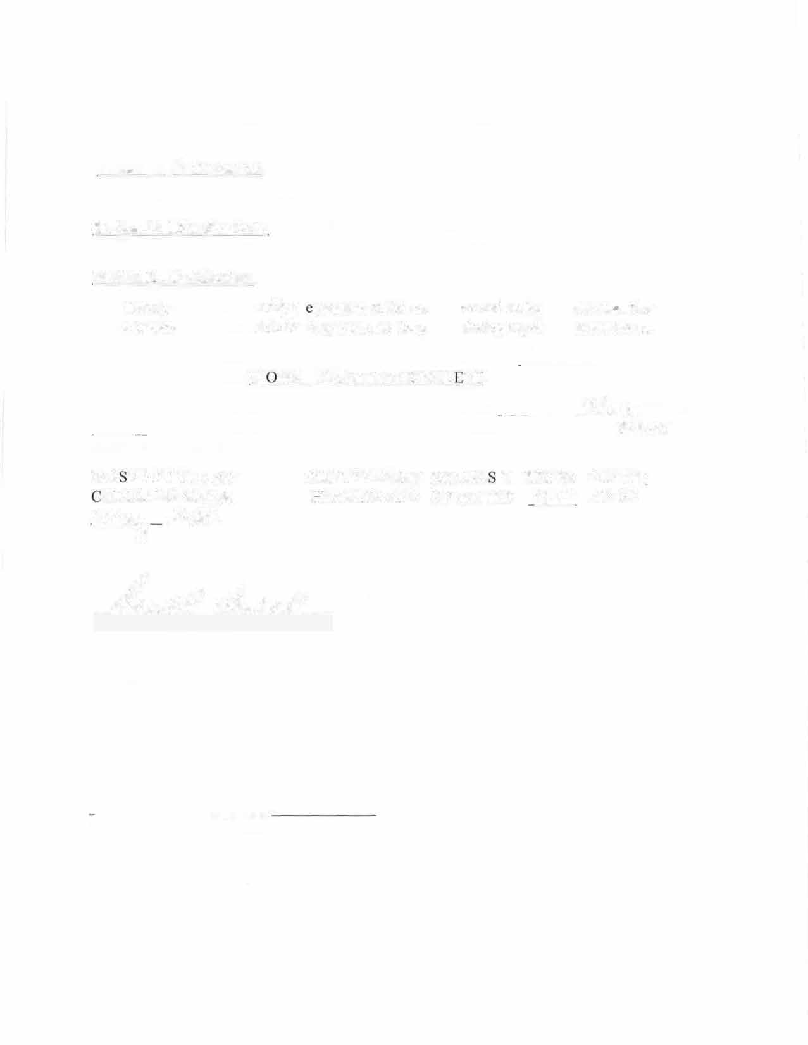

**Section 10. Enforcement.**

The provisions of this Ordinance shall be enforced by the Kiowa County Sheriff.

**Section 10. Effective Date.** This Ordinance shall take effect thirty (30) days after the final publication of its adoption by the Board of County Commissioners.

**Section 11. Certification.**

The Countty Clerk shall certify the passage of this ordinance and make not less than three copies of the adopted Code available for inspection by the public during regular business hours.

**INTRODUCED, READ, ADOPTED ON FIRST READING** on �l ***ll*** -' 2024, and

J

ordered published in the KIOWA COUNTY INDEPEND ·NT.

PUBLIC HEARING A ND SECOND READING will be on the */LJ�ay* of�2024 at

/t>: t:>D , *A.MIPM* at the Basement Meeting Room, Kiowa County Courthou;:-1�off Street, Eads, Colorado

PA S ED BY THE BOARD OF COUNTY COMMISSIONER OF KIOWA COUNTY OLORADO AFTER A PUBLIC HEARING AND SIGNED THIS '3c,+1,-,. DAY OF

*vyyz�*

,

20

M.

***����---«=-�""""'---'bc?d?�-*** s-/Yd/2eJg_y

Donald Oswald, Chairman

ATTEST:

Delisa Weeks, Kiowa County Clerk & Recorder